Project Design Phase – 2 Data flow diagram & Users Stories

|  |  |
| --- | --- |
| Date | 15 October 2022 |
| Team ID | PNT2022TMID49320 |
| Project Name | SmartFarmer-IoT Enabled Smart  Farming Application |
| Maximum Marks | 4 Marks |

**Data Flow Diagram (Simplified):**

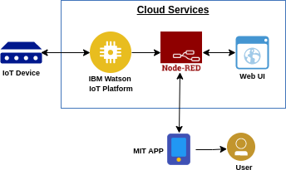

**Data flow diagram:**

